Case Study #2 – Personal Finance

Directions: Complete the following parts. Please submit to Canvas by 11:59 pm on March 31, 2025.

- (5 pts) Research the job you want to get after college. Use the website http://www.bls.gov/ooh/education-training-and-library/home.htm.
- What is the job you have chosen? Give a brief description of the job.
- How will your time at Bryant make you eligible for this job?
- What is the annual salary for this job?
- Determine the yearly salary after taxes (about 75% of the annual salary)
- Determine the monthly salary after taxes.

- (12 pts) A common rule of thumb is to spend 10–15% of your monthly income on car payments. Research the car you would like to have once you graduate. You can use websites like cars.com, autotrader.com, carmax.com, or any other website you find. Try to find a car that is in the area that you will live after graduation.
  - What website did you use?
  - Provide a brief description of the car. What is the make, model, year and price of the car?
  - Attach a picture of the car.
  - Assume that you have to pay the full amount of the car, and that the loan will be for 6 years or 72 months (the average length of car loans right now). Use the credit score you have or think you will have upon graduation. Remember no credit=bad credit! What interest rate did you use? What are your monthly payments?
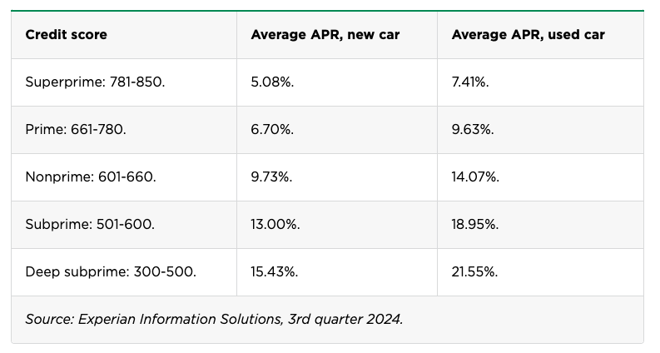
  - What is 10% of your monthly salary? What is 15% of your monthly salary? Are the car monthly payments within the suggested 10-15% of your monthly salary?
  - Determine the total amount paid over the term of the loan.
  - How much interest was charged over the term of the loan?
  - What percentage is paid toward the interest? Round to the nearest whole percent.

- (5 pts) Many experts recommend saving 20% of your monthly salary.
  - What is 20% of your monthly salary?
  - Imagine you can put this amount into an annuity every month earning 5.65% for 45 years (the average length of careers in the US). How much money do you have after 45 years?
  - How much money did you contribute over the 45 years?
  - How much interest did you earn over the 45 years?

- (5 pts) Here are two ways of investing $30,000 for 20 years.

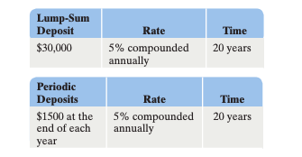

  - How much money will there be after 20 years in the lump-sum deposit (compound interest)?
  - How much interest will be earned in the lump-sum deposit?
  - How much money will there by after 20 years in the annuity (periodic deposits)?
  - How much interest will be earned in the annuity?
  - After 20 years, which account has more money? How much more does it have?

- (3 pts) Reflection: In 3 sentences, reflect on what you learned in the personal finance unit.

Some possible questions you can answer:
- What surprised you?
- How does this topic connect to your life?
- What was the most important concept covered?
- What questions do you still have?
- What new perspectives did you gain?
- How has your understanding of the topic changed?

